BEIT DIN
Beit Din means House of Justice, and at Temple Shalom we will act as a Court of Law for Tzedakah and Tikkun Olam programs in Religious School. We will learn about values and mitzvot, discuss ways to perform them in our community, and include all of the school/Temple to help, from collecting items to holding an event.

Beit Din is open to all students in grades K to 5th.
Contact Melanie Schwartz for more information at mel.b.schwartz@gmail.com

Meeting Dates
Our meetings will usually take place after Religious School classes on Sundays from 11:30AM to 12PM in Room 2.

9/17 Kickoff
9/24 Picnic and Park Clean-Up (11:30AM-1:30PM) with adult chaperone
10/22
11/12
11/19
12/3
12/10
1/7
1/28
2/4
2/25
3/18
4/8
4/22
5/6
Park Clean Up with Beit Din
Who: Kindergarten through 5th graders with an adult chaperone
What: Picnic lunch and cleaning up the park
(Please bring your own picnic lunch/beverage and blanket)
When: Sunday 9/24, Meet in Room 2 after class at 11:30
From there we will drive/walk over to the park.
Where: Meadowbrook Local Park
Why: To make the world a cleaner and more beautiful place, and to do a mitzvah!

Please RSVP to Melanie Schwartz at mel.b.schwartz@gmail.com by Saturday 9/23. Thank you!
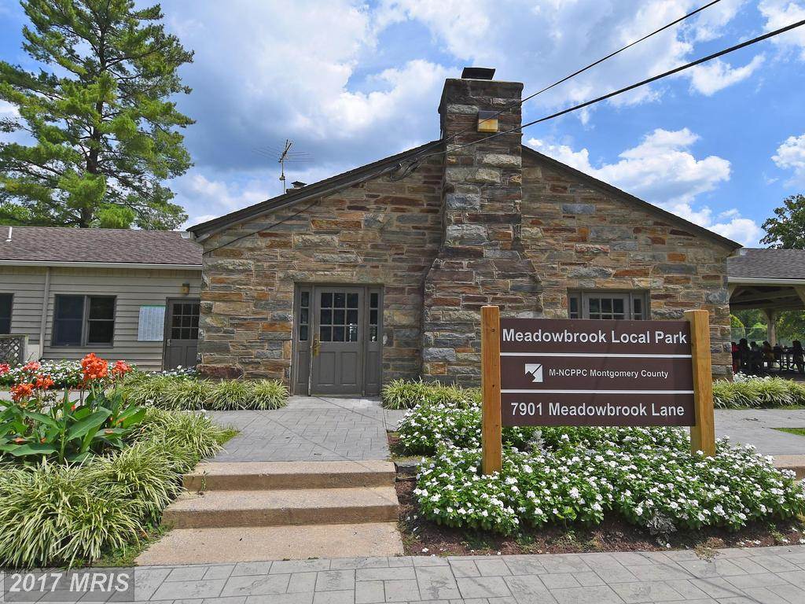

Yes, sign me up for Beit Din!

Name __________________________________

Grade _____

Student Signature

_____________________________________

Email to receive news and schedule updates

__________________________________

I support my child’s participation in the Temple Shalom Religious School Beit Din.

Parent Name

______________________________________

Parent Signature

______________________________________

